NUNIT AND MOQ:
- NUnit-Handson

OBJECTIVE:
1. What is Unit Testing?
Answer:
Unit testing is the process of testing the smallest unit of code (usually a method or function) independently to check if it works correctly. Dependencies are often replaced using mocking.

2. What is Functional Testing?
Answer:
Functional testing checks whether the complete functionality of an application works according to the requirements. It tests the system from the user's point of view.

3. Difference between Unit Testing and Functional Testing
Unit Testing | Functional Testing
Tests a single method/function | Tests complete features
Done by developers | Done by testers or developers
Fast | Slower
Uses mocks | Uses real components
Finds coding errors | Finds requirement/functionality issues

4. What is Mocking?
Answer:
Mocking means creating a fake object to replace a real dependency during testing. It helps test only the required unit.

5. What are the types of testing?
Answer:
- Unit Testing
- Functional Testing
- Automated Testing
- Performance Testing

6. What is Automated Testing?
Answer:
Automated testing uses tools or scripts to run test cases automatically without manual effort.

7. What is Performance Testing?
Answer:
Performance testing checks how fast, stable, and scalable an application is under different workloads.

8. What are the benefits of Automated Testing?
Answer:
- Saves time
- Reduces manual work
- Increases accuracy
- Can run repeatedly
- Detects bugs early

9. What is Loosely Coupled Design?
Answer:
Loosely coupled design means classes have minimum dependency on each other, making the code easy to test and maintain.

10. What is Testable Design?
Answer:
Testable design means writing code that can be easily tested without depending on external classes or resources.

11. Why should code not depend directly on another class for data?
Answer:
It reduces dependency, makes testing easier, and improves code flexibility.

12. What is NUnit?
Answer:
NUnit is a unit testing framework for C# used to write and run test cases.

13. What is [TestFixture]?
Answer:
[TestFixture] marks a class that contains test methods.

14. What is [Test]?
Answer:
[Test] marks a method as a test case.

15. What is [SetUp]?
Answer:
[SetUp] runs before every test method to prepare test data.

16. What is [TearDown]?
Answer:
[TearDown] runs after every test method to clean up resources.

17. What is [Ignore]?
Answer:
[Ignore] skips a test case during execution.

18. What is [TestCase]?
Answer:
[TestCase] is used to run the same test method with different input values.

19. What are Parameterized Test Cases?
Answer:
Parameterized test cases allow one test method to test multiple inputs using [TestCase].

20. Why are Parameterized Tests useful?
Answer:
- Reduce duplicate code
- Test multiple inputs easily
- Improve code readability
- Save time

21. Write a simple calculator addition test.
Answer:
[TestFixture]
public class CalculatorTest
{
[Test]
public void TestAddition()
{
Calculator cal = new Calculator();
Assert.AreEqual(10, cal.Add(5, 5));
}
}

22. Why is Unit Testing important?
Answer:
- Finds bugs early
- Improves code quality
- Makes code easier to maintain
- Supports safe code changes

23. Who mainly performs Unit Testing?
Answer:
Developers.
24. Who mainly performs Functional Testing?
Answer:
Testers (QA) or developers.

25. What is the main goal of Unit Testing?
Answer:
To verify that each individual method or function works correctly.

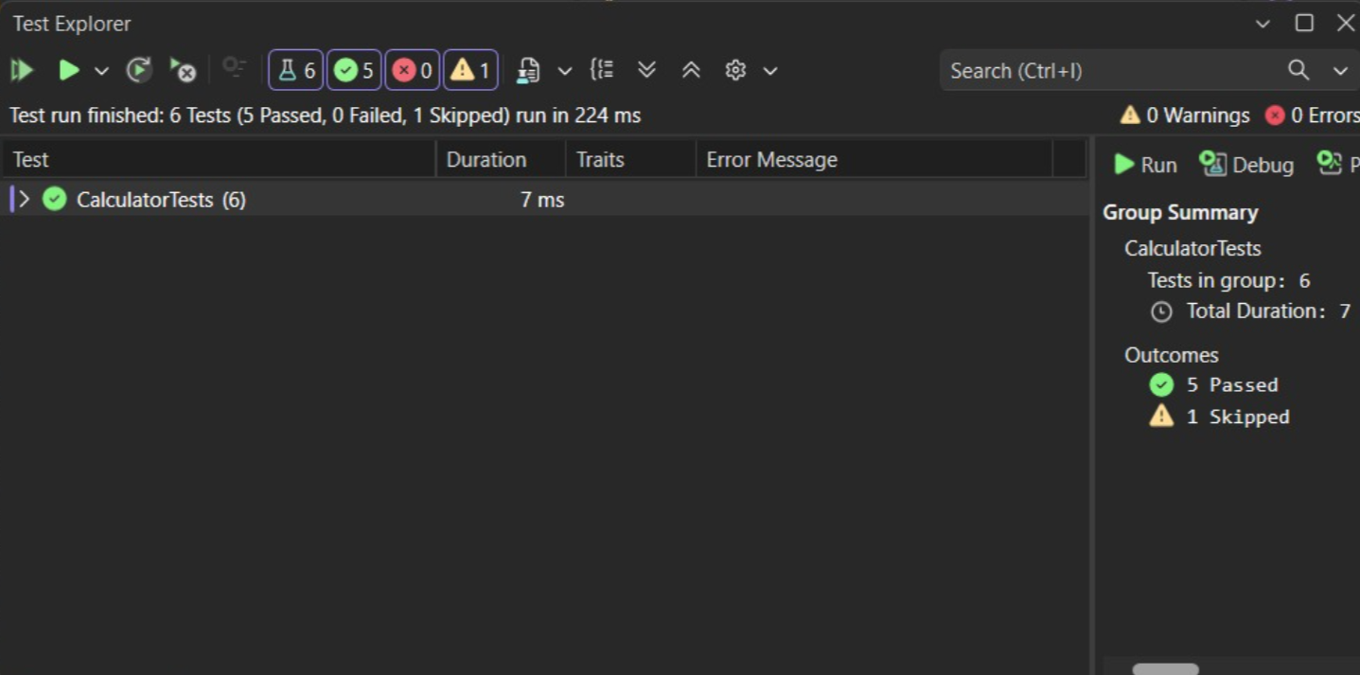
- Moq-Handson
- Write Testable Code with Moq

1.IMailSender.cs
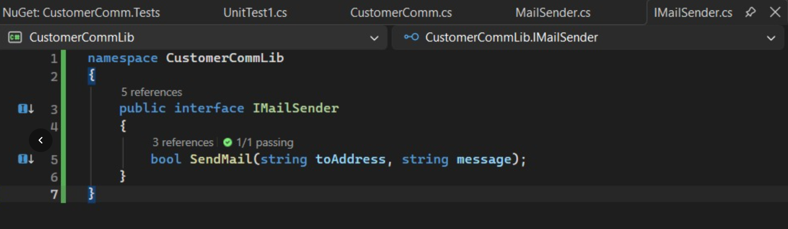
2.MailSender.cs

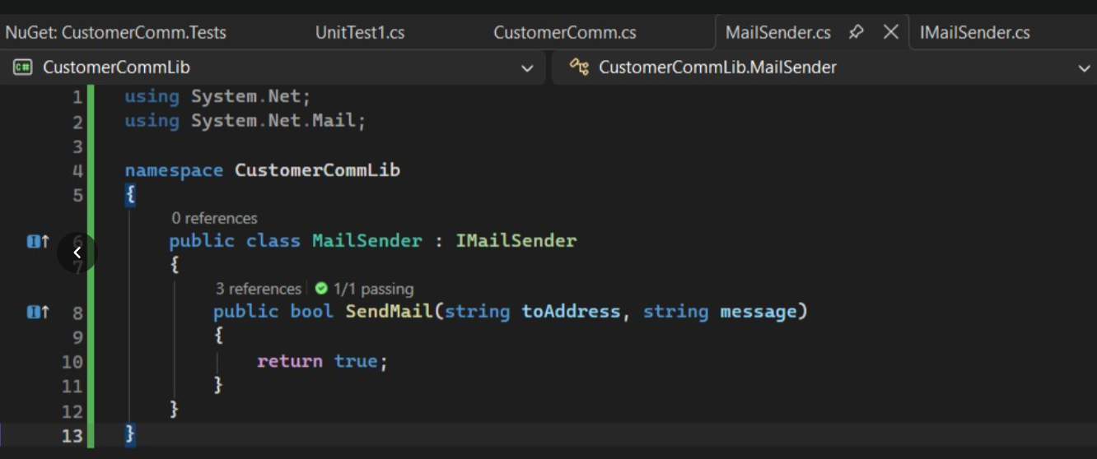

3.CustomerComm.cs
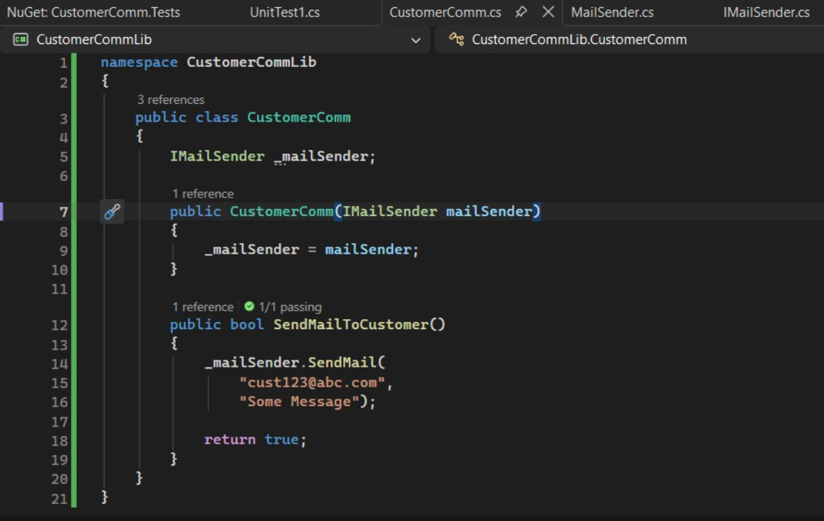
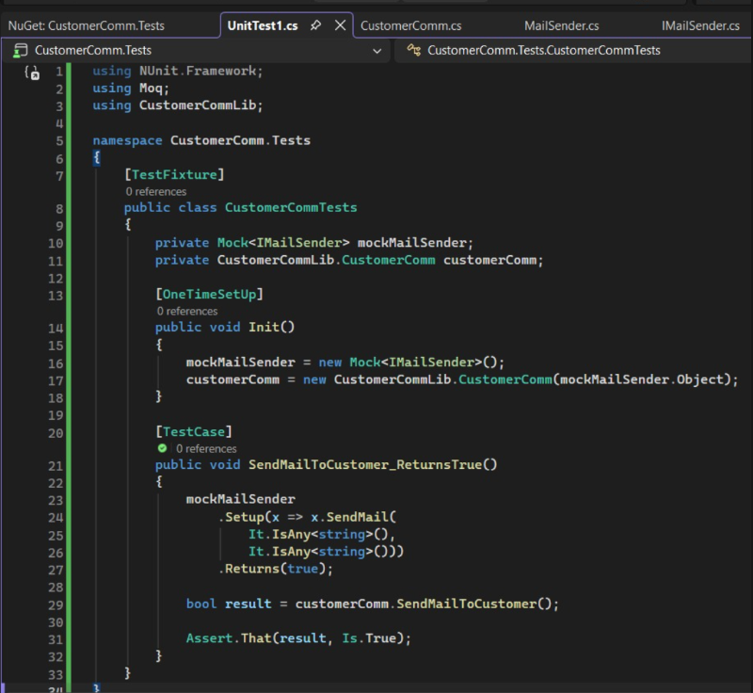
4. UnitTest1.cs

